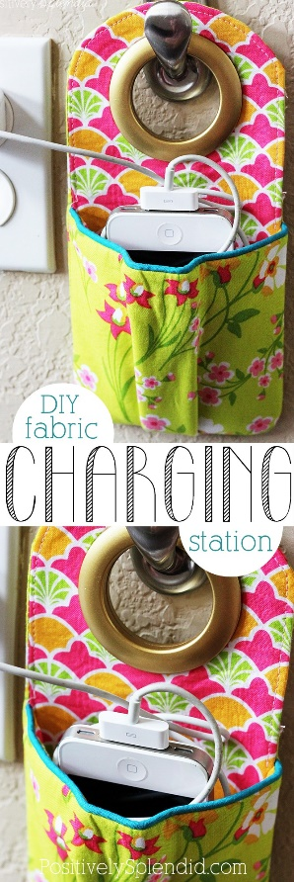
#3 DIY Fabric Phone Charging Station - Positively Splendid {Crafts, Sewing, Recipes and Home Decor}
Materials needed: Fabric in 2 coordinating patterns (scraps or fat quarters work nicely)
Printed paper pattern: Portable-Phone-Charging-Station.pdf (If you print, print this 100%, do NOT fit to page) I will make several copies.

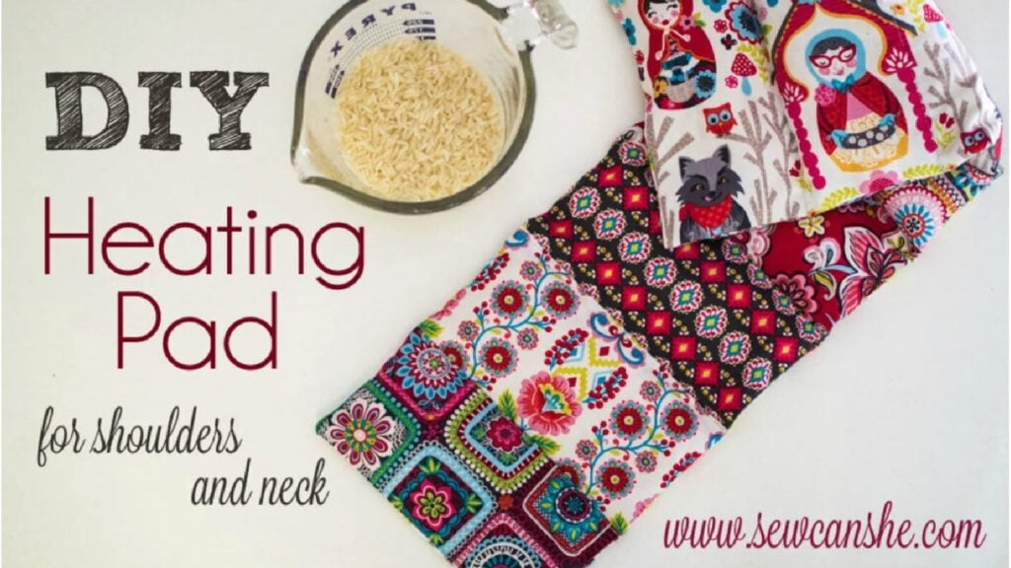

#1 Make a Heating Pad for shoulders and neck
- 8 strips of fabric 3 1/2” x 6 1/2”} essentially (Scraps, or fat quarters of 2-8 multiple fabrics) Fewer = less variation in scrap top.
- 1 backing strip 6 1/2” x 24 1/2” ( Buy 1/4 yard= 9” x approx 40” wide) NOT A FAT QUARTER
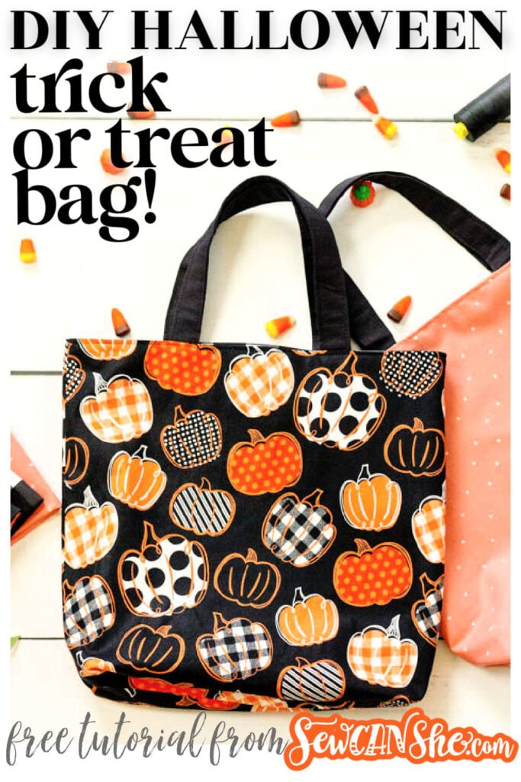

#2 How To Make A Halloween Trick Or Treat Bag: Easy And Fun
- 1/2 yard of cotton fabric for the bag exterior
- 1/2 yard of cotton fabric for the bag lining
- optional: two 4” x 14” pieces of a different fabric for the handles

